

Network;

Conv +BN+RELU : 8 stages

Skip connections: 5 stages

Simulation Results:

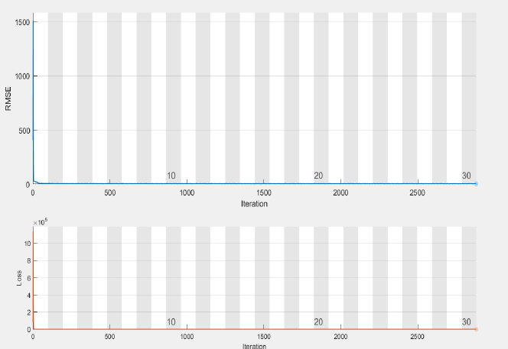

RMSE and Loss curve



|  |  |
| --- | --- |
|  |  |
| Noisy Parrot Image | [5] 25.8 dB |
|  |  |
| [8] 26.1 dB | [14] 25.9 dB |
|  |  |
| [15] 26.4 dB | Proposed 27.2 dB |

Comparison of DnCNN and RCNN for data set of 12 images

|  |  |  |  |  |
| --- | --- | --- | --- | --- |
| **Image** | **PSNR**  **DnCNN** | **PSNR**  **Proposed** | **SSIM**  **DnCNN** | **SSIM**  **Proposed** |
| **1** | 20.43 | 22.76 | 0.89 | 0.88 |
| **2** | 21.63 | 23.41 | 0.87 | 0.89 |
| **3** | 21.00 | 23.04 | 0.84 | 0.86 |
| **4** | 20.79 | 22.80 | 0.91 | 0.92 |
| **5** | 21.28 | 23.34 | 0.88 | 0.85 |
| **6** | 21.01 | 23.00 | 0.86 | 0.91 |
| **7** | 21.09 | 22.80 | 0.87 | 0.92 |
| **8** | 21.78 | 23.34 | 0.85 | 0.84 |
| **9** | 20.46 | 22.24 | 0.92 | 0.91 |
| **10** | 21.00 | 23.01 | 0.84 | 0.86 |
| **11** | 21.46 | 22.95 | 0.85 | 0.88 |
| **12** | 21.03 | 22.88 | 0.86 | 0.90 |

[5] K. Dabov, A. Foi, V. Katkovnik, and K. Egiazarian, “Image denoising by sparse 3-D transform-domain collaborative filtering,” *IEEE Trans. image Process.*, vol. 16, no. 8, pp. 2080–2095, 2007.

[8] S. Gu, L. Zhang, W. Zuo, and X. Feng, “Weighted nuclear norm minimization with application to image denoising,” in *Proceedings of the IEEE conference on computer vision and pattern recognition*, 2014, pp. 2862–2869.

[14] D. Zoran and Y. Weiss, “From learning models of natural image patches to whole image restoration,” in *2011 international conference on computer vision*, 2011, pp. 479–486.

[15] A. Levin, B. Nadler, F. Durand, and W. T. Freeman, “Patch complexity, finite pixel correlations and optimal denoising,” in *European Conference on Computer Vision*, 2012, pp. 73–86.